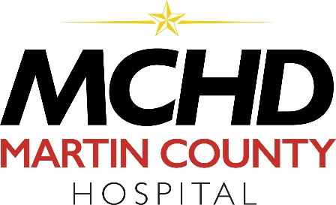

June 3, 2021
Press Release

Martin County Hospital District has completed the refinancing of the District’s outstanding bonds for a lower interest rate. This will create significant savings for the taxpayers of Martin County.
The Series 2021 bonds were sold via negotiated interest rates with the underwriters, led by SAMCO Capital Markets. The final interest rate on the refinanced bonds is 2.31%. These replace the Series 2011 bonds which had interest rates between 6.75% and 7.25%. Based on the results of the bond sale, the refinancing will save $7,882,954 over the life of the transaction (over $500,000, annually through 2036).
Chief Financial Officer, Tony Glisan stated, “we are pleased to be able to obtain this savings for Martin County residents. Moody’s Investment Service gave the bonds a rating of A3 and Fitch rated them at BBB+. This shows the strong financial position of the Hospital District.”
Proceeds from the Series 2011 bonds were used for the original construction cost of Martin County Hospital and Martin County Family Clinic located at 600 Interstate 20 East.
Specialized Public Finance, Inc. assisted with the refinancing.

